Milestone 2:

During the attempt to recreate QADroid studies and test, I ran into an issue when trying to run the offline project portion of the tool. It ran into this problem when trying to read the android jdk. I added the classpath to the JDK gotten from android studio, but when trying to execute the code the following error occurs

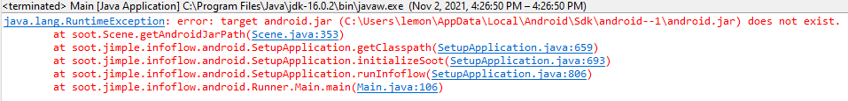

Because of the following exception

It is not finding the JDK and that is causing problems for running the tool. I’ve tried investigating the exception and changing environment information, but no solution seems to progress passed this error. A code change could be made but that does not seem like a valid solution as it is not testing their tool but also changing it.

The solution is to email the creators if available, and if they do not respond or are not reachable, then a different approach will be chosen, and the focus will shift to a project involving the inspection of flowdroid which is the underlying tool used.